Notes on 3G Gateway

**!! 3G networks in the United States are set to be sunset by the end of 2022 !!**

3G gateways should continue to work in areas with continued 2G coverage but most likely at reduced performance.

# ****Upgrading to LPWA (Low-Power Wide Area Networks for IoT)****

Acclima designed the radios to be modular and are easily switched out. To remove a 3G radio and replace it with a LPWA radio:

You’ll need:

* Small wrench (8mm)
* Phillips screwdriver
* Small flathead screwdriver (optional)

1. Unscrew the nuts with the wrench and remove the washers from the antenna connectors. A small flathead screwdriver may help lift the washers off.

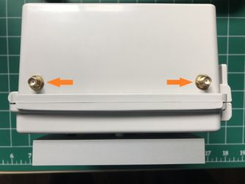

1. Remove the battery and set safely aside. Unplug the solar panel and unscrew the three screws holding the microcontroller card to the back of the enclosure.

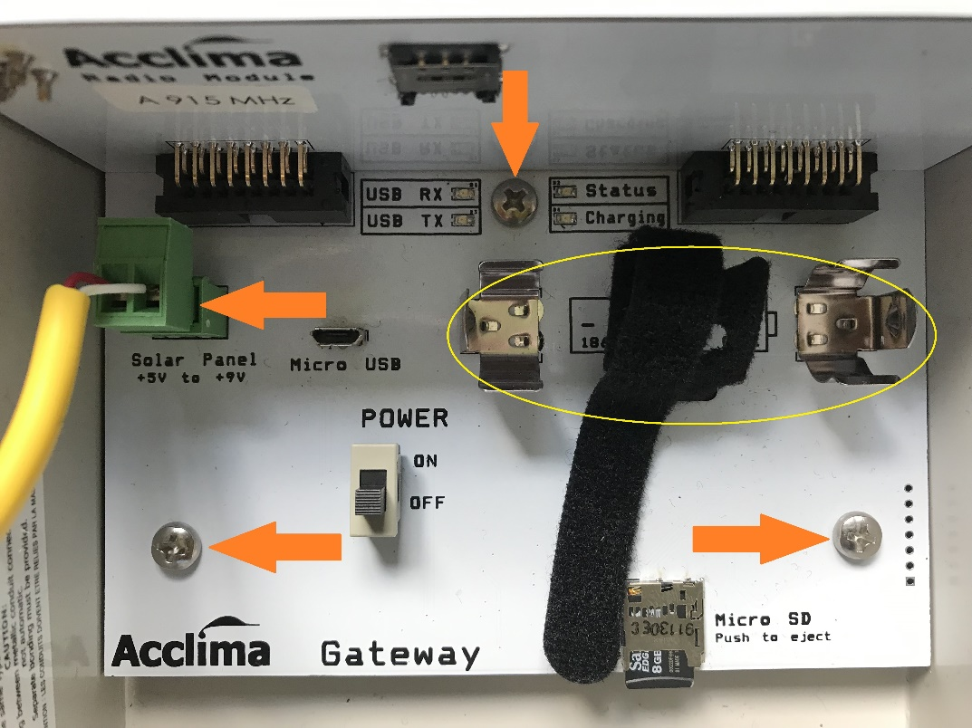

1. Push down on the antenna connectors to pull out the card assembly.

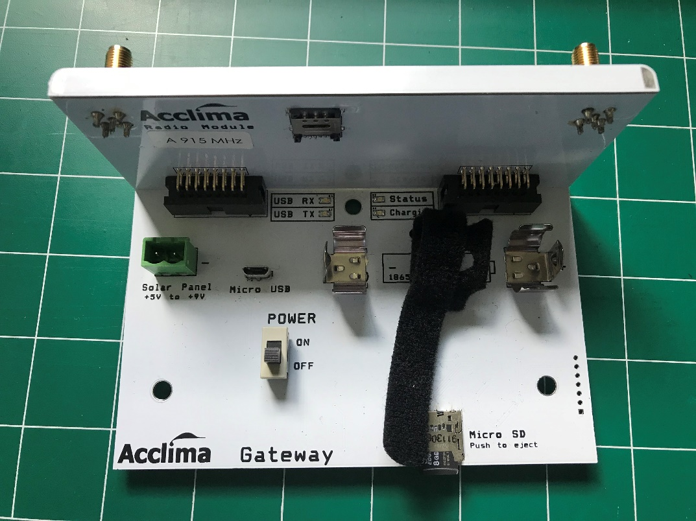

1. Pull the radio card apart from the microcontroller card.

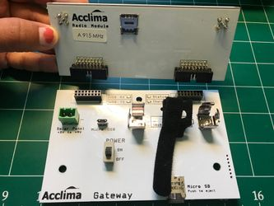

1. Connect the new radio card to the microcontroller card.

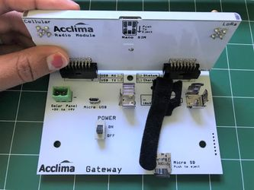

1. Replace the card assembly into the enclosure. Replace all screws and nuts. Reconnect the solar panel and battery.

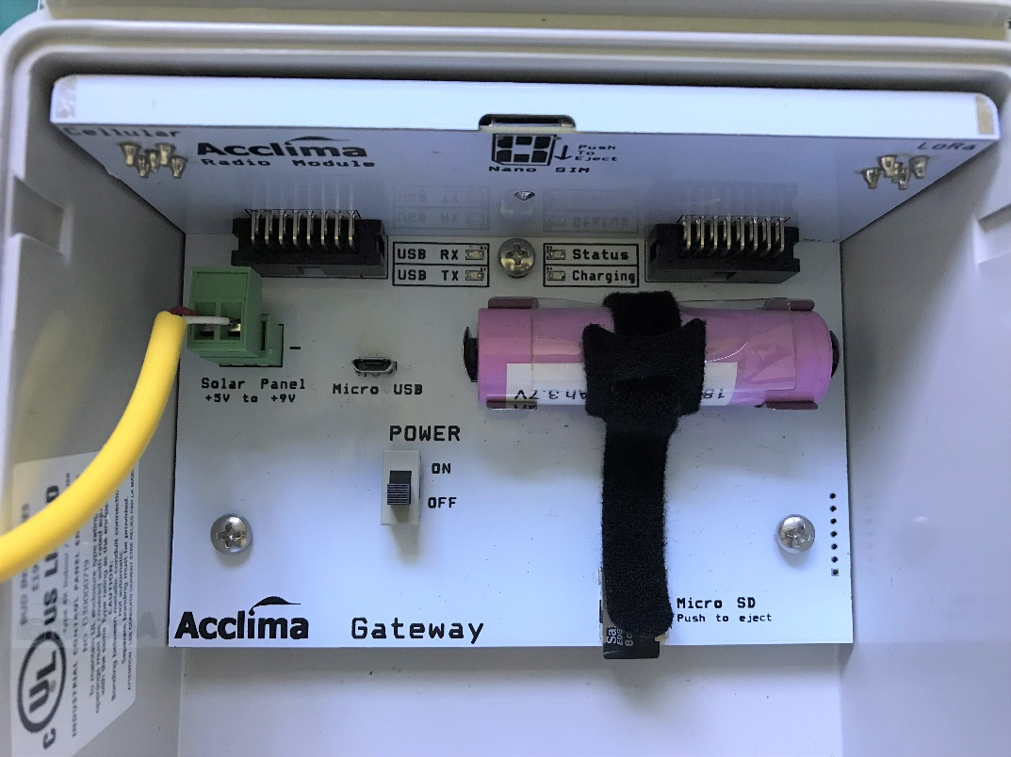

# ****Setting Up a New 3G Unit****

Upload and run FONA3G_setbaudAIT.ino.hex first on new units. This sketch sets the cellular modem's baud rate to 4800 and only needs to be run once. The microcontroller and modem will not communicate correctly if the hardware baud rate does not match what is set in the firmware.